Membership Status | Description | Annual  Fees | Special  Rates* | Joining Fees**
Family | 2 Seniors, all children living at home & full time students up to 25 years of age | £325 | £290 | £30
Senior | Must have been born in 2000 or earlier (except students) | £155 | £140 | £25
Full time Student | Born since 1996 (proof still a student if born earlier) | £56 | £51 | £10
Junior | Must have been born in 2001 to 2008 inclusive | £56 | £51 | £10
Mini | Must have been born in 2009 to 2014 inclusive | £36 | £33 | £0
Tot | Must have been born in or after 2015 | £0 | £0 | £0
Country Member | Senior and resident 20 miles or more from Abergavenny | £105 | £95 | £15
Special Needs |  | £56 | £51 | £10
Social Member | Access to clubhouse and mini tennis playing area only | £20 | £20 | £0
* Special Rates: to attract the Special Rates, Annual Fees must be received before 1 April 2020.
** Joining Fees: Joining Fees are required from all new and lapsed members.
Applicant Name(s)  First name Surname | Membership  Status  (as above) | M/F | Date of birth  (if under 21) | Aged  18-40  Yes/No | Aged  Over 40  Yes/No | Annual Fee  £ | Joining Fee  (if applicable)  £ | Total  £
Child Protection: The Club takes photographs of members at events/competitions for publicity including website and newspaper articles. If you would not like your child’s photograph to be used please tick this box □ |  |  |  |  |  |  | Total £  for the  Household

I/We hereby apply to join the club and agree to the club rules. The household contact should sign the form and provide the details requested.
Print name (must be parent’s name for under 18s) | Signed  (on behalf of all applicants)
Full Address (including postcode) | Email Address
Home Telephone | Mobile Telephone
Advise us here if any of the applicants have any medical conditions
that you would like the club or the coaches to know about.

I/we are happy that the information supplied can be used to receive communication about ATC club activities and will not be shared with any third parties other than to confirm membership of ATC with the LTA, in line with the club’s privacy policy displayed on the notice board.
Please tick this box to receive updates on club activities □
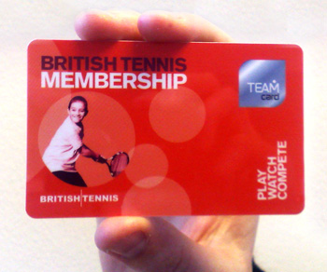
We are an LTA-affiliated club so you also qualify for free British Tennis Membership (BTM)
Go to: https://www.lta.org.uk/member/ to sign up for BTM

It is the responsibility of all members of ATC to ensure they have a BTM number which is assigned to ATC and is essential for members who want to enter the LTA Wimbledon ticket ballot.

